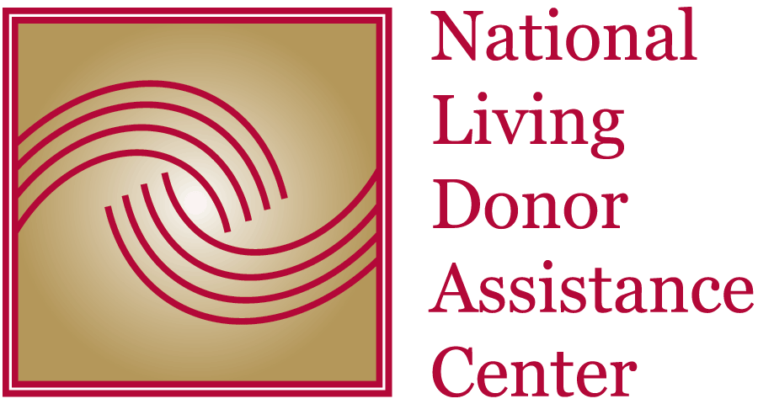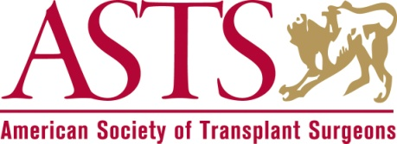

FOR IMMEDIATE RELEASE
Media Contact:
Diane Mossholder
703-414-7870
diane.mossholder@asts.org

Lost Wages Reimbursement for Living Organ Donors Trial Announced

Arlington, VA – December 21, 2016: The National Living Donor Assistance Center (NLDAC) announces that it will conduct a randomized controlled trial that will assess the impact of interventions intended to remove financial barriers to living organ donation through wage reimbursement.
NLDAC was established in 2007 to administer a grant funded by the U.S. Health Resources and Services Administration to provide greater access to transplantation for persons who want to donate, but cannot afford the travel and subsistence expenses associated with donation. It currently provides travel and subsistence funds for nearly 1000 people per year who wish to become living organ donors to offset their expenses related to donation.
Living donors usually travel at least three times to the transplant center and are required to stay near the hospital for up to two weeks after the transplant surgery for monitoring. They are unable to work during their donation and recovery time, and the loss of wages can be a significant financial barrier. This study will provide data to help answer the question of whether removing that barrier increases living donation in the United States.
The Laura and John Arnold Foundation provided funding for the trial, which will be administered by the American Society of Transplant Surgeons in partnership with the Arbor Research Collaborative for Health, with additional researchers from University of Arizona, the Wharton School of the University of Pennsylvania, and Mayo Clinic Arizona. Five transplant centers with active living donor transplant programs will participate in the trial.
“Removing financial disincentives to organ donation has long been a goal of ASTS,” said Timothy L. Pruett, MD, president of the American Society of Transplant Surgeons (ASTS). “I’m pleased that we are able to conduct this trial and gather data on the extent to which the prospect of lost wages discourages donors from coming forward or even being asked to consider donating. With more than 120,000 people waiting for an organ in the United States, we must do everything possible to ensure that those willing to donate are able to do so without financial harm to themselves or their families.”

“Our study design – potential transplant recipients will be randomly offered or not offered wage reimbursement for their donors – incorporates a high level of scientific rigor,” noted Robert M. Merion, MD, president and CEO of Arbor Research Collaborative for Health. “When the study is completed, we will know much more about the role played by lost wages as a barrier to living organ donation, and the extent to which removal of that barrier leads to more living donor transplants and improved lives for patients. We are delighted that the Laura and John Arnold Foundation has recognized the societal importance of this question.”

The trial will begin in 2017 and is projected to run through 2018.

###
About NLDAC
The National Living Donor Assistance Center (NLDAC) was established in 2007 to provide greater access to transplantation for persons who want to donate, but cannot otherwise afford the travel and subsistence expenses associated with donation. The program is funded by grant number U13HS07689 from the Healthcare System Bureau, Health Resources and Services Administration, U.S. Department of Health and Human Services. It is administered by the American Society of Transplant Surgeons, University of Arizona Health Sciences, Arbor Research Collaborative for Health, Washington University – Missouri, and Mayo Clinic – Arizona. For more information, visit LivingDonorAssistance.org.

About ASTS
Established in 1974, the American Society of Transplant Surgeons (ASTS) is the oldest abdominal organ transplant society, serving approximately 1,800 surgeons, physicians, scientists, pharmacists, coordinators, and advanced transplant providers. ASTS is committed to fostering the practice and science of transplantation and guiding those who make policy decisions by advocating for comprehensive and innovative solutions to the needs of our members and their patients. ASTS is a nonprofit organization in Arlington, Virginia. For more information, visit ASTS.org.

About Arbor Research
Arbor Research Collaborative for Health is committed to improving patient care through research that shapes medical policies and practice. In particular, Arbor Research conducts health outcomes research on chronic disease and end-stage organ failure, with expertise in biostatistical analysis, clinical practice, health economics, public policy, database management and integration, and project coordination. Through research projects that are national and global in scope, Arbor Research’s scientific collaborations provide valuable and timely information to the worldwide health care community. A full description of the project portfolio is available at ArborResearch.org.

About the Laura and John Arnold Foundation
LJAF is a private foundation that is working to improve the lives of individuals by strengthening our social, governmental, and economic systems. It has offices in Houston, New York City, and Washington, D.C. www.arnoldfoundation.org.

